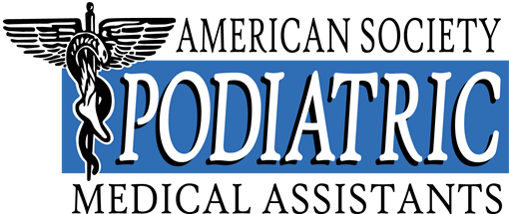

EXECUTIVE DIRECTOR’S REPORT

ANNUAL BUSINESS MEETING – March 2025

As Executive Director, it is my duty to have all legal papers filed in a timely fashion. Our incorporation papers are in effect and handled through Bishop, Rossi and LaForte, LTD. in Oak Brook Terrace Illinois. Our trademark and registered name are in effect until April 28th, 2032, and our authority to conduct business in Illinois is effective until February 1st, 2026. Our Biennial Report for non-profit corporation has been filed and our organization is in good standing until April 1st, 2026. We are also an Affiliated Organization of the APMA, and the papers submitted to maintain that status have also been approved for this year.

The Executive Director also serves as the Treasurer of the organization. The financial status of the ASPMA is stable as all funds have been deposited and all bills are paid to date. An accounting service, Hovey’s Accounting and Tax Services, Inc. is employed to file our taxes annually. I also review our investments with our finical advisor Robert Signorella, MBA,BBA,CPA from Cetera Financial Specialists in Oak Brook Terrace on an annual basis.

All correspondence directed to my attention have been answered and all required reports have been filed.
I continue to answer the calls on the ASPMA toll free phone line. And respond to e-mails in a timely manner.

I have reviewed the salaries of our board for 2025 with our President and Vice President.

I process all the credit card payments.

I mail all payroll checks to the board by the 25th of each month.

I assisted Tara Brown and Kim Reider with the mailing of the clinical, radiology and administrative study guides.

I have been accepting the membership reinstatement forms and forwarding them on to the executive board for their review.

I attend the monthly Zoom meetings scheduled by our President.

I have submitted my monthly report to the auditing committee.

I attended the ASPMA Retreat in Scottsdale, AZ from January 16th to 20th, 2025.

I helped plan the 10th Annual Complications Course Assistants program September 27th and 28th, 2024 in Naperville, IL along the Michele Bradice.

House of Delegates: I will be attending the 2025 APMA House of Delegates in Washington DC on March 13th – 16th, 2025.

Midwest Podiatry Conference 75th Annual Meeting:
I will be attending the Midwest Podiatry Conference March 4th to 9th 2025 at the Hyatt Regency Downtown, Chicago, IL.
I have booked the hotel rooms for our board.
I am presently booking airline tickets for our board.
Registered our board for the meeting.
I secured the booth in the exhibit hall and requested exhibitor name badges for several board members.

76th Annual Region III Meeting:
The dates are May 7th – 9th, 2025 at Harrah’s Resort in Atlantic City. I will do the mailing for the meeting registration when the schedule is completed. I have been working with Denise Savastano manager of catering and convention services, regarding our room requirements and coffee service each day.

APMA National Meeting Dallas-Fort Worth, TX:
I am waiting on the contract with Meghan McClelland, MBA Executive Director of the APMA for the 2025 APMA Scientific Meeting at the Gaylord Texan Resort and Convention Center Dallas-Fort Worth, TX
I secured the contract for our copper sponsorship.
I secured the booth in the exhibit hall and requested exhibitor name badges for board members.

It is such an honor to serve as Executive Director during this year. I pledge to work closely with the new Board. Be proud of ASPMA, it is a growing and viable organization.

Respectfully submitted,
Karen M. Keathley, PMAC,PRAC,PAAC
Karen M Keathley, PMAC, PRAC, PAAC
Executive Director

