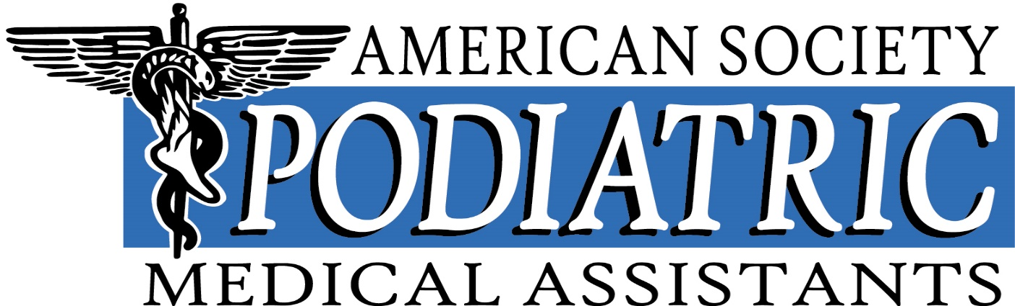

Qualifying and Examining Report
Annual Business Meeting
March 7, 2025

As Chair of the Qualifying and Examining Committee I have successfully completed all tasks and requirements asked of me.
I have certified all qualifying members of the ASPMA for online clinical and administrative exams.
From April 2024 through January 2025 there have been 55 total new registrations for exams: 49 registrations for the PMAC exam, 6 registrations for the PAAC exam. 27 new PMAC certifications issued. 4 new PAAC certifications issued. 4 failed exams, 3 clinical and 1 admin.
I have responded to all correspondence from members, assistants and inquiries regarding certification.
I have sent out all study guides to members who have registered for the PMAC Clinical and PAAC Administrative certification.
I have responded to all internet and phone inquiries regarding certification.
I have sent electronic and hard copy certificates to assistants who have met the requirements of certification.
I have completed monthly reports to the auditing committee.
I have attended the National Conference in Washington DC, August 2024. I attended and lectured at the Heartland Conference in Des Moines, October 2024.
Respectfully submitted,
Kim Reider, PMAC, PRAC, PAAC
Q & E Chair, ASPMA

